Is this report confidential? | No
Report of | Meeting | Date
Service Lead Audit and Risk | Governance Committee | Tuesday, 24 May 2022
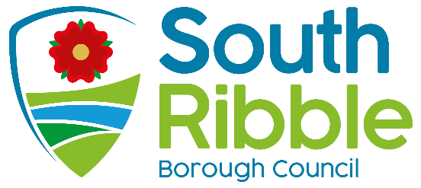

Internal Audit Annual Report and Opinion 2021-2022

Purpose of the Report
- The purpose of this report is to summarise the work undertaken by the Internal Audit Service during 2021/2022 and to give an opinion as required by the Public Sector Internal Audit Standards (PSIAS) on the adequacy and effectiveness of the Council’s framework of governance, risk management and control.

- The report also includes the results of the Quality Assurance and Improvement Programme.

Recommendations to Governance Committee
- That the Committee is asked to note the report for the year ended 31.3.2022.

Reasons for recommendations
- The completion of an Annual Audit Report and Opinion is a requirement of the Public Sector Internal Audit Standards.

Other options considered and rejected
- None.

Corporate priorities
- The report relates to the following corporate priorities: (please bold all those applicable):

An exemplary council | Thriving communities
A fair local economy that works for everyone | Good homes, green spaces, healthy places

Background to the report
- The Service Lead Audit and Risk is responsible for the delivery of an Annual Internal Audit Report and Opinion that can be used by the council to inform its Annual Governance Statement.

- The attached report complies with the requirements of the PSIAS. It includes details of the coverage of work undertaken and a summary of the work that has been carried out that supports the opinion.

- It also states whether the work has been undertaken in conformance with PSIAS, the results of any Quality Assurance Improvement Programme (QAIP), summary of actual performance against targets/measures and any issues that are considered relevant to the preparation of the AGS.

Climate change and air quality
- The work noted in this report does not impact the climate change and sustainability targets of the Councils Green Agenda and all environmental considerations are in place.

Equality and diversity
- The material presented and discussed in this report has no direct implications on equality and diversity.

Risk

The primary role of the Audit and Risk Service is to provide assurance or otherwise that the council is effectively managing its risk and to provide support to all Directorates in relation to risk and control.

Comments of the Statutory Finance Officer
- No comments.

Comments of the Monitoring Officer
- No comments.

There are no background papers to this report

Appendices
Appendix A – Internal Audit Annual report and opinion 2021- 2022
Appendix B – Summary of Work undertaken 2021-22
Appendix c – Performance Indicators 2021-22
.

Report Author: | Email: | Telephone: | Date:
Dawn Highton (Shared Service Lead- Audit & Risk) | dawn.highton@southribble.gov.uk | 01772 625625 | 12/5/22

